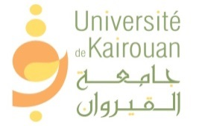

Call for Applications

ERASMUS+ INTERNATIONAL STAFF MOBILITY at the WEST UNIVERSITY TIMISOARA, Romania
Call for Applications International Credit Mobility
Academic year 2022/2021

Target public
Administrative Staff
Number of motilities: 1

Fields of Education and Training:
All area
Eligibility Requirements for Erasmus Staff
  - Staff willing to participate in the programme must be employed and actively working at the University of Kairouan that signed the Interinstitutional Agreement within the framework of Erasmus + Programme, with the West University TIMISOARA, Romania
  - B2 Level of English Proficiency
Mobility periods:
Staff Mobility for training: 5 days (9th -13th May 2022)
Application Procedures

Selection criteria:
  - The scientific and academic quality of the application;
  - Motivation of the candidate
Required documents
  - Training agreement for administrative staff (Annex II) signed by the applicant and confirmed by the home institution.
  - Knowledge of English (B2 Certificate)
  - Copy of the Passport
  - European CV – Europass
  - Motivation letter
  - Vaccination certificate
  - Proof of staff employment
Deadline for applications: February 24, 2022.
Note :
  - All documents in Arabic or French should be translated into English language.
  - The staff must be preselected and nominated by the University of Kairouan
  - The University of Kairouan will be responsible of selection procedures on the basis of transparent and fair criteria.
  - To apply for this opportunity, please send your applications (in one pdf file) to icmunivk@gmail.com
Contacts:
For any information, you can contact Ms Mahbouba BELLAR by e-mail: mahbouba.bellar@gmail.com

